**PHY 481 Midterm:**

**Quantification of Photon Flux of UV-LED Driven Photocatalysis**

Student Researcher: Niall O Gushue

Advisor: Dr. Brian Frederick

In our study we aim to quantify the photon flux of our UV-LED’s and apply this information to various photocatalytic reactions such as the degradation of methyl orange11 and the photocatalytic conversion of methane to methanol.2 In Phase 1 of the project we worked on engineering a constant current power supply capable of powering the previously designed UV-LED lamps. We ordered a 12V DC power supply from digikey that comfortably powers the two UV-LED lamp design (Vmin = 7.4V). Wired connections were made to the live (black), neutral (white), and ground (green) components of the power supply to allow it to be plugged into the 120V wall socket (Figure 1).

Figure 1. A) Power supply before connections and B) after connection were made

The 120V wall socket was measured with a multimeter to determine the live, neutral, and ground components of the socket and cross-checked to ensure compatibility with that of the power supply’s plug. Due to safety concerns, the power supply has not yet been plugged into the wall socket as supervision from the research advisor for this task is necessary. The next step of engineering the power supply was to design the “constant current” component. The idea for the design of this circuit was to choose the simplest circuit possible. We played with the idea of using various diode and transistor circuits, but eventually decided to use the circuit element known as an LM317 due to the complexity of these transistor circuits. An LM317 is an adjustable positive linear voltage regular that can be operated using an input voltage between 3 – 40 V, but will always deliver an output voltage of Vout = 1.2 ± 0.05 V. The LM317 has an input, output, and adjust terminal; the adjust terminal ensures the output terminal voltage is always 1.2 V higher. Using the properties of the LM317 a functional constant current circuit powered by the 12V power supply was developed as illustrated in Figure 2.

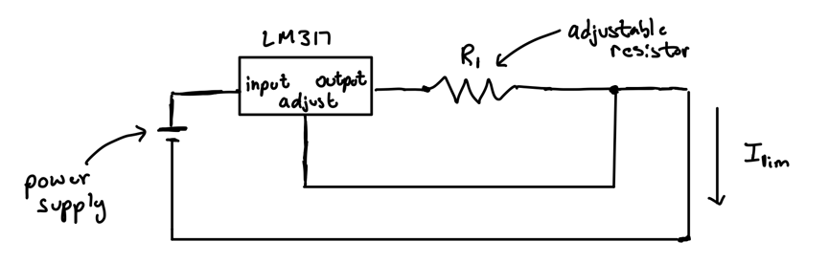

Figure 2. LM317 motivated constant current power supply circuit

The limited current (Ilim) of this circuit can be controlled by the adjustable resistor of this circuit described by Equation 1.

(1)

The standard current for running photocatalytic reactions with UV-LEDs is 500mA, therefore the necessary resistance of the adjustable resistor (Ωmax = 5Ω) should be 2.4 Ω for these experiments. Unfortunately, there are two constraints to the current power supply design; 1) the chosen power supply voltage output limits the number of LEDs on the lamps to three LEDs (Vmax = 11.1 V) and 2) the adjustable resistors have a maximum resistance of 5Ω and can only limit the current to a minimum of 240 mA which is well above the desired limited current of 10 mA. Therefore a resistor of ~120 Ω is necessary to make measurements with the integrating sphere.

To quantify the photon flux of the UV-LEDs with our ocean optics integrating sphere, we must use software the compatible with this instrument. The integrating sphere must be calibrated with a calibration light source before any measurements photon flux measurements can be made. We downloaded the ocean optics software on an old computer running Windows XP and acquired an ocean optics calibrating light source (LS-1-CAL). We familiarized ourselves with the ocean optics software and investigated a method for calibrating the integrating sphere and developed a procedure for calibrating the integrating sphere with the calibration light source. To properly calibrate the light source, the software manual recommends an intensity of 3500 counts which requires an integration time of 4500 ms. Due to the low processing capability of the computer being used, the computer tends to crash upon trying to start an absolute irradiation measurement necessary for calibration. To prevent the system from crashing, the program must be allowed to run for ~1 hour after changing the integration time which limits the number of measurements that can be made in a day. Using a low intensity red LED that would not burn out the sensors on the integrating sphere, we were successfully able to measure its radiant flux following the calibration procedure (Figure 3).

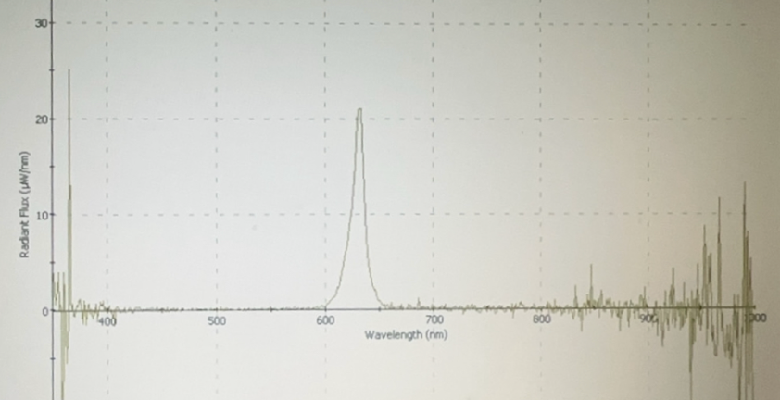

Figure 3. Radiant flux vs. wavelength of a red LED

This suggests that radiant flux measurements of the UV-LED at low current is possible with the integrating sphere. However, Takanabe *et al.* stress the importance of making accurate photon flux measurements in order to successful characterize the success of photocatalytic reactions.3 The high noise in the UV region is problematic for making accurate UV radiant flux and adjustments to the calibration procedure is necessary for accurate radiant flux measurements.

The original project proposal suggests studying the photocatalytic conversion of methane to methanol. This reaction is difficult to study and requires refinement of the analytical techniques with the GC-MS. Therefore, for characterizing the photon flux of our LEDs in this stage will be done by studying the kinetics of methyl orange degradation as outlined by Bakar *et al*.1 This reaction is studied by plotting the initial rate of the degradation as a function of photocatalyst mass until an “optimal rate” is achieved as suggested by Takanabe *et al*.3 Over the course of two weeks, kinetic measurements of nanographi TiO2 (denoted NG) and nanographi TiO2 calcined to 450°C (denoted NG 450) were made and plotted In Figure 4 with previous measurements of United States Research (USR) TiO2 catalyst .

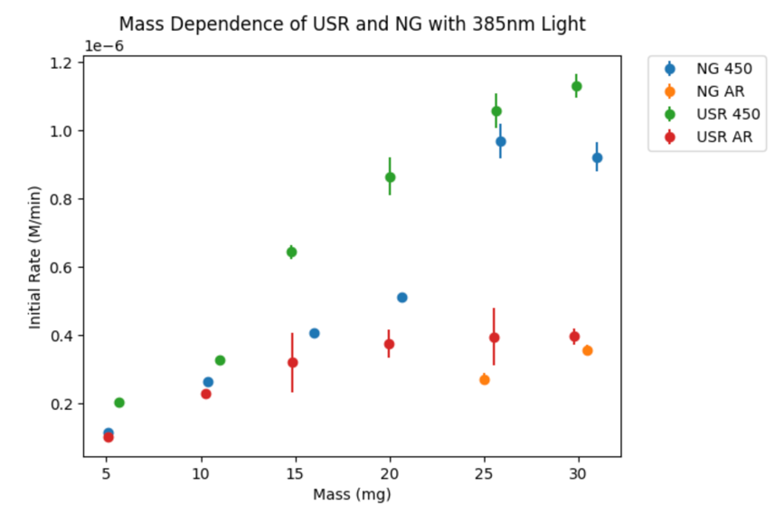

Figure 4. Mass dependence of USR and NG Photocatalyst

The data suggests that calcining improves the photocatalytic activity of our catalyst. We believe this to be a result of the deep sulfur-induced electron traps.4 We would like to characterize these sulfur-induced traps further by measuring low sulfur containing catalysts. The current experimental set-up limits the number of data points collected (2 points per day). By implementing the new constant current power supply, these reactions can be run without the need to adjust the current from voltage fluctuations. As a result, multiple reactions can be run concurrently improving the efficiency of data acquisition to 6 points per day. Adjustments and development for measuring the radiant flux of the UV-LED lamps can be achieved by fine-tuning the calibration procedure and purchasing a higher resistance resistor. By developing a method to determine the photonic efficiency for the methyl orange degradation reaction we can more easily study the photonic efficiency for a much more difficult reaction to run such as the methane to methanol reaction.

**References:**

1 S.A. Bakar, and C. Ribeiro, “Rapid and morphology controlled synthesis of anionic S-doped TiO 2 photocatalysts for the visible-light-driven photodegradation of organic pollutants,” RSC Adv. **6**(43), 36516–36527 (2016).

2 M.A. Gondal, A. Hameed, Z.H. Yamani, and A. Arfaj, “Photocatalytic transformation of methane into methanol under UV laser irradiation over WO3, TiO2 and NiO catalysts,” Chemical Physics Letters **392**(4–6), 372–377 (2004).

3 M. Qureshi, and K. Takanabe, “Insights on Measuring and Reporting Heterogeneous Photocatalysis: Efficiency Definitions and Setup Examples,” Chem. Mater. **29**(1), 158–167 (2017).

4 A. Rahmani Chokanlu, A. Mahdavi-Shakib, L. Yu, T.J. Schwartz, R.N. Austin, and B.G. Frederick, “Direct Evidence for Sulfur-Induced Deep Electron and Hole Traps in Titania and Implications for Photochemistry,” J. Phys. Chem. C **127**(14), 6754–6767 (2023).